|  |  |
| --- | --- |
| cetlogo ***CHEMICAL ENGINEERING TRANSACTIONS***  ***VOL. xxx, 2025*** | A publication of  aidiclogo_grande |
| The Italian Association  of Chemical Engineering  Online at www.cetjournal.it |
| Guest Editors: Fabrizio Bezzo, Flavio Manenti, Gabriele Pannocchia, Almerinda di Benedetto  Copyright © 2025, AIDIC Servizi S.r.l. **ISBN** 979-12-81206-17-5; **ISSN** 2283-9216 | |

Design and fabrication of 3D-printed capsules for enhanced bioavailability of dronedarone hydrochloride with omega-3 fatty acids

Gordana Matijašića, Teodora Prebega, Emanuel-Nino Fialab, Mirta Logarc

aUniversity of Zagreb Faculty of Chemical Engineering and Technology, Trg Marka Marulića 19, Zagreb, Croatia

bGenera d.d. (Dechra Pharmaceuticals PLC), Svetonedeljska cesta 2, Kalinovica, Croatia

cUniversity of Zagreb Faculty of Mechanical Engineering and Naval Architecture, Ivana Lučića 5, Zagreb, Croatia

gmatijas@fkit.unizg.hr

The aim of this study is to develop and 3D print a capsule containing dronedarone hydrochloride as the primary active ingredient in a polymer filament and omega-3 fatty acid powder as an excipient. The research hypothesis is that the bioavailability of dronedarone hydrochloride is increased by the presence of omega-3 fatty acids. A capsule was formulated and evaluated that allows the simultaneous administration of dronedarone hydrochloride and omega-3 fatty acids. Prior to the 3D printing process, a 3D capsule model was developed using CAD software. Filaments were then extruded with two formulations containing 10 % and 15 % dronedarone. The capsules were then filled with omega-3 fatty acid powder and the *in vitro* release of dronedarone was tested. Capsules with and without omega-3 fatty acids were tested. The release profiles of dronedarone were compared and the differences were quantified using difference and similarity factors.

The results showed that the samples with omega-3 fatty acids had a faster *in vitro* release of dronedarone than the samples without this excipient. In addition, a faster release was observed in samples with a higher dronedarone content in the filament, which can be attributed to an increased driving force. The difference and similarity factors showed a statistically significant difference in the release profiles of dronedarone from capsules with omega-3 fatty acids compared to capsules without this excipient.

* 1. Introduction

In the pharmaceutical industry, drug development is a multi-stage process that takes up a lot of time and resources. Since the 1960s, the industry has relied on established production processes and formulation concepts to ensure product stability and mass production. After a long period of limited advances in manufacturing, new technologies have emerged that could revolutionize the pharmaceutical sector (Trenfield et al. 2018). One relatively new technology is 3D printing, which offers modern opportunities to transform the industry. In particular, 3D printing can be used to produce small quantities of orally administered tablets or capsules. Each printed medicine could have a customized dose, shape, size and release profile. This production method could finally make personalized medicine a reality (Awad et al. 2018).

The first approved and marketed 3D-printed tablet is Spritam®, which is used to treat epilepsy. Since then, a variety of drug formulations have been produced – some with altered geometry and release properties, while others combine multiple active pharmaceutical ingredients (APIs). The number of patents began to increase in the 1980s and now stands at over 300, with around 10 pharmaceutical products currently marketed, including Abbott's Kaletra, Pfizer's Rezulin, medical devices such as Merck's Nuvaring and implants such as Allergan's Ozurdex (Goyanes et al. 2015; Khaled et al. 2014). Spritam® was developed by Aprecia Pharmaceuticals using patented ZipDose technology for the 3D printing of drugs and enables the rapid disintegration of high-dose drugs. Its main advantage is its highly porous structure, which allows the tablet to dissolve immediately on contact with saliva, reducing the time from ingestion to effect and helping patients with dysphagia (Martin 2018).

In the early stages of drug development, flexible dosing is critical. 3D printing allows for easy dose adjustment by changing the dimensions or infill density of the tablet. In the early stages of development, including laboratory and clinical trials, it is important to minimize investment in materials, equipment and labor. This is facilitated by 3D printers, which are inexpensive, compact and easy to prototype (Trenfield et al. 2018).

Mass production in the pharmaceutical industry usually results in a few standardized drug doses that meet the needs of the majority. However, it is clear that a single dose is not suitable for everyone, as patients' needs vary depending on their genetic profile, disease state and factors such as age, gender and body weight. There is also a growing number of patients with swallowing difficulties. For this reason, the Precision Medicines Initiative was launched in the United States in 2015 to promote the idea that every patient should receive a personalized dose of medication, moving away from "one size fits all". For children, it can be a challenge to adhere to prescribed therapy. 3D technology can simplify this by creating different dosages and combinations of medications that match individual preferences for color or shape. This approach personalizes medication and is particularly beneficial for children, who can receive their own customized product and thus improve adherence to therapy (Preis and Öblom 2017). The three main benefits of personalized medicine that can be achieved through 3D printing include dose customization, tailored release profiles and multi-ingredient tablets. Goyanes et al. (2017) have shown that customized drug release profiles can be achieved with 3D-printed dosage forms. They concluded that 3D printing using fused deposition modeling (FDM) enables the production of sustained release dosage forms without the need for external enteric coatings. In addition, the release profile can be tailored to individual patient characteristics by changing the print settings and using appropriate excipients and polymers (Basit and Gaisford 2018). Khaled et al. (2015) have developed the most remarkable example of a multidrug dosage form. They succeeded in producing a tablet with five active ingredients – aspirin, hydrochlorothiazide, atenolol, ramipril and pravastatin. This “polypill” with different release profiles is intended for patients with cardiovascular disease. By integrating multiple drugs into a single dosage form, 3D printing solves the challenges of treating diseases that require multiple tablets and reduces the risk of intentional or unintentional medication errors. (Basit and Gaisford 2018).

3D printing technology has some limitations. For example, powder-based 3D printing requires a specialized environment and monitoring due to potential health risks from powder residues. In addition, certain technologies are limited to specific materials (e.g. FDM only supports thermoplastic polymers, while selective laser sintering (SLA) uses photopolymerized oligomers). The mechanical resistance also depends on the technology used. Extrusion printing produces mechanically weaker structures than FDM, which produces more robust shapes.

The aim of this research is to model and 3D print a capsule with several active ingredients. Dronedarone hydrochloride, an antiarrhythmic drug, was selected as the active ingredient. The active ingredient was incorporated into the polymer filament. The capsule model was designed to contain omega-3 fatty acids in its outer cavities to improve the bioavailability of dronedarone. From a chemical engineering standpoint, the capsule design plays a crucial role in mass transfer and controlled release. The spur gear-shaped core increases the surface area, potentially enhancing dissolution and diffusion dynamics, which is essential for optimizing drug delivery systems.

* 1. Materials and Methods

This section introduces the materials used, explains the preparation of the filaments, describes the design of the capsule model, outlines the printing preferences, describes the *in vitro* test procedure and concludes with the data analysis.

* + 1. Materials

Dronedarone Hydrochloride

Dronedarone hydrochloride (DNR) belongs to the group of benzofurans, which consist of heterocyclic rings. Its molecular mass is 593.22 g/mol and its density is 1143 kg/m³. In this experiment, it was used as an active ingredient in the treatment of cardiovascular diseases due to its antiarrhythmic properties.

Poly(vinyl alcohol)

A commercially available poly(vinyl alcohol) (PVA) filament from Formfutura was used for printing dosage forms. PVA is a synthetic polymer with the molecular formula (C2H4O)n. Its glass transition temperature is 85 °C and its melting temperature is between 180 and 190 °C. The density of PVA is between 1.25 and 1.35 g/cm³ at 25 °C. PVA is used for the packaging of cosmetics and as fibers in textile production, but is mainly used as an emulsifier in the chemical, food and pharmaceutical industries.

Poly(ethylene glycol)

Poly(ethylene glycol) (PEG) is a polyether compound with repeating ethylene glycol units. It is a water-soluble solid used in the pharmaceutical, textile, metal and wood industries. PEG is also non-toxic and very elastic, which is why it is often used as a plasticizer. In this study, PEG with a molar mass of 20,000 g/mol was used, which is manufactured by Merck KGaA.

Omega-3 fatty acids

Omega-3 fatty acids are categorized into alpha-linolenic acid (ALA), which is found in vegetable oils such as soybean, flaxseed and rapeseed oil, and eicosapentaenoic acid (EPA) and docosahexaenoic acid (DHA), which are found in fatty fish and fish oils. A dietary supplement consisting of omega-3 powder (Proteos d.o.o., Croatia) was used in the study. The powder consists mainly (50%) of cod liver oil, which is tasteless and 100 % water-soluble. One gramme of the powder contains 70 mg EPA and 50 mg DHA, which corresponds to 7 % EPA and 5 % DHA.

* + 1. Filament Preparation

Two filaments were prepared from PVA, PEG and DNR. First, a solid dispersion of PEG and DNR was prepared by melting at 50 °C. Once the mixture solidified, it was broken into small pieces and mixed with crushed PVA fragments. Two formulations, F10 and F15, were prepared containing 10 % and 15 % DNR by mass, respectively. In addition, these formulations contain 10 % and 15 % PEG, while F10 contains 80 % PVA and F15 contains 70 % PVA. The filaments were produced by extrusion at a temperature of 170 °C and a screw speed of 60 rpm in a NoztekPro extruder.

* + 1. Capsule Model Design

The capsule model was designed using Fusion 360 software. The inspiration was the heart as a vital organ and main drive of the body, symbolizing the central role of the DNR in the treatment. Therefore, the capsule core was designed in the form of a spur gear (Figure 1a). A shell was designed around the gear, closed on one side and open on the other, to allow filling with omega-3 fatty acid powder (Figure 1b).

a) 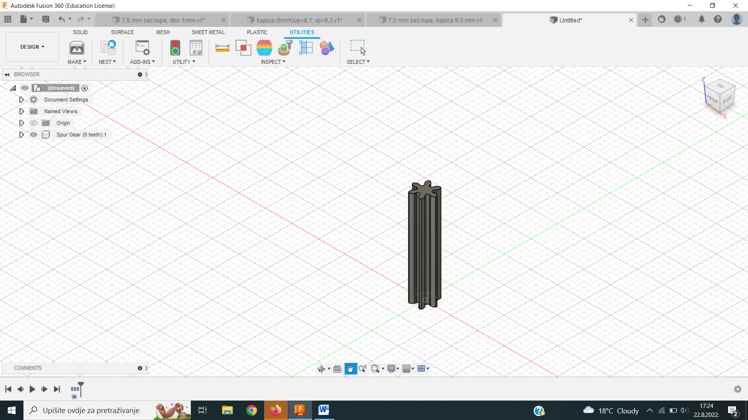 b)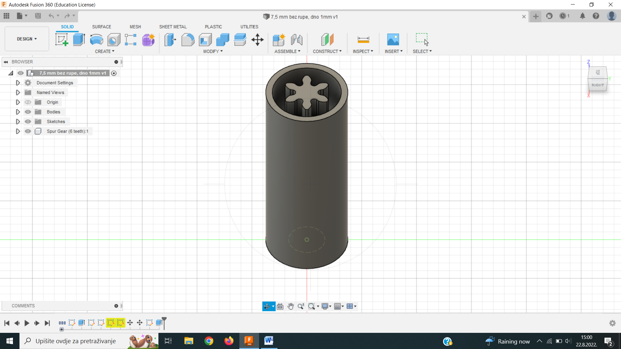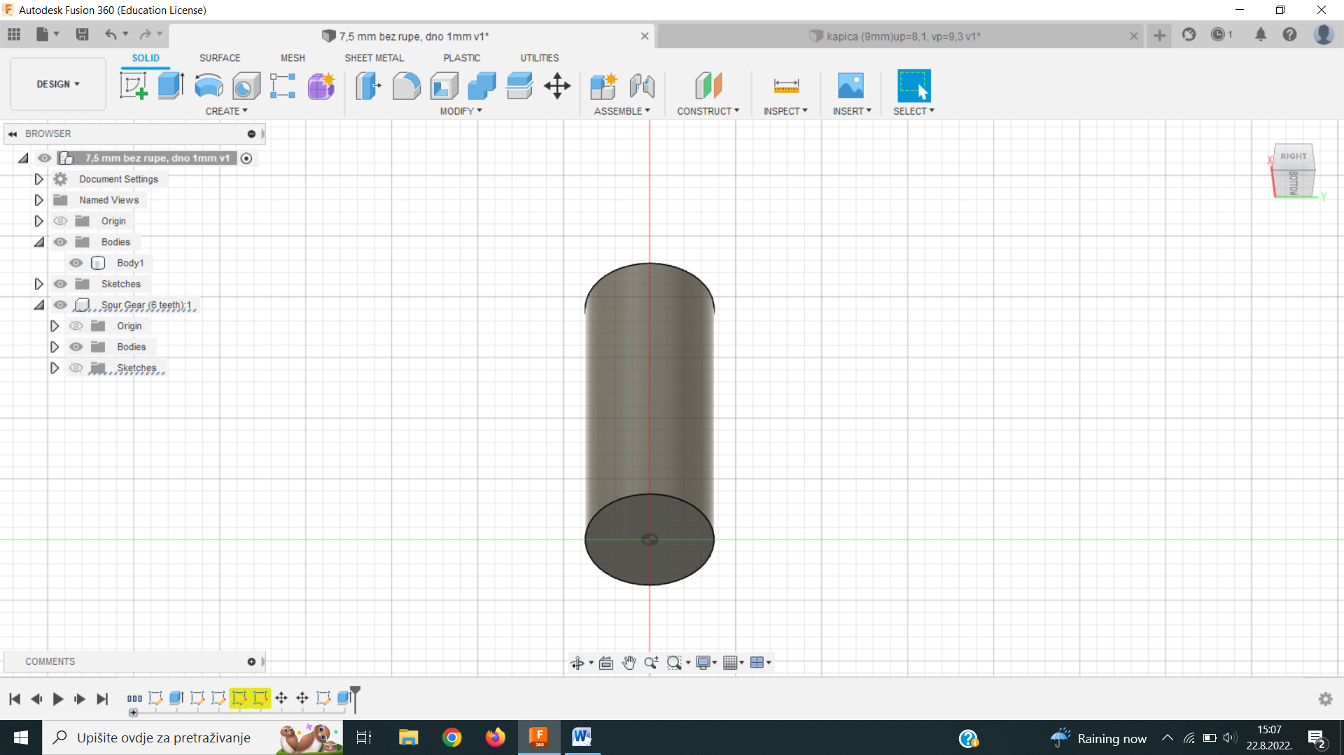 c) 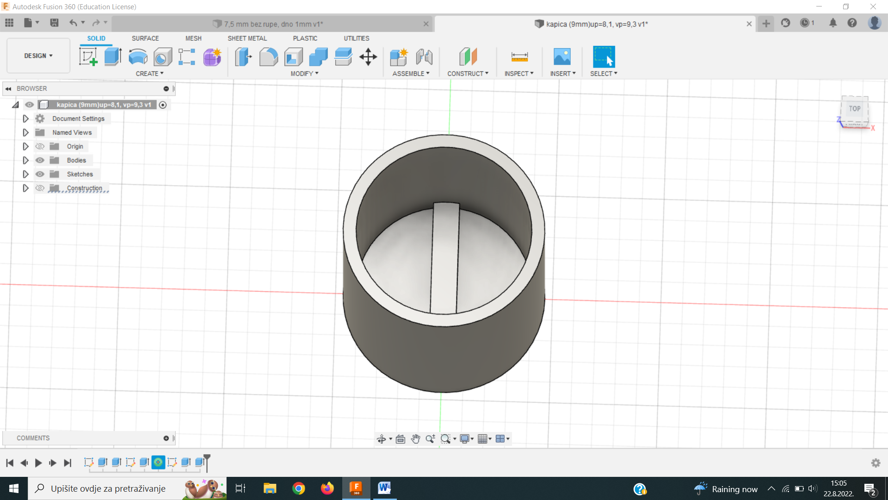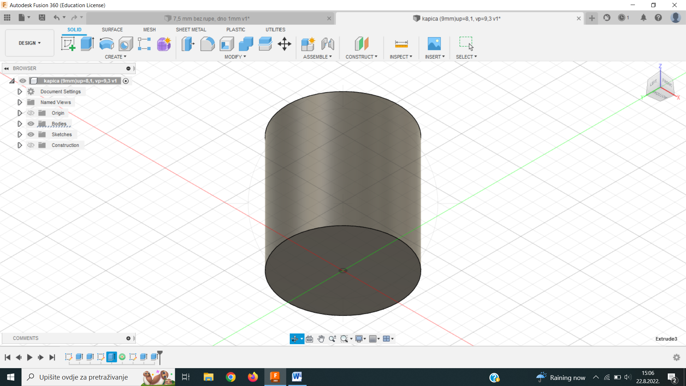

*Figure 1: a) Spur gear of the capsule core, b) top and bottom view of capsule body and c) cap.*

Table 1: Capsule dimensions

|  |  |  |
| --- | --- | --- |
| Model |  | Dimensions, mm |
| Gear | Height | 18.00 |
|  | Outer diameter | 4.40 |
|  | Inner diameter | 2.02 |
| Capsule body | Height + bottom | 18.00 + 1.00 |
|  | Wall thickness | 0.60 |
|  | Outer diameter | 7.50 |
|  | Inner diameter | 6.30 |
| Cap | Height + bottom | 9.00 + 0.80 |
|  | Wall thickness | 0.60 |
|  | Outer diameter | 9.30 |
|  | Inner diameter | 8.10 |
| Crossbar | Height | 1.20 |
|  | Width | 0.80 |
|  | Length | 8.50 |

After filling, the capsule is closed on one side with a cap (Figure 1c) which is intended to close the capsule securely. Inside the cap, near the base, there is a crossbar which serves to distribute the omega-3 powder evenly in the capsule. Capsule dimensions are given in Table 1.

* + 1. 3D printing

For the experiment, a Flashforge Inventor 3D printer was used, which works according to the principle of Fused Filament Fabrication (FFF). The printing conditions are listed in Table 2.

Table 2: 3D printing preferences

|  |  |  |
| --- | --- | --- |
| Parameter | Left nozzle (PVA) | Right nozzle (DNR) |
| Capsule element | Capsule body and seal | Spur gear body |
| Infill density | 100 % | 100 % |
| Nozzle temperature | 195 °C | 185 °C |
| Platform temperature | 50 °C | 50 °C |
| Printing speed | 30 mm/s | 30 mm/s |
| Additional support | Wall | Wall |

* + 1. *In Vitro* Drug Release Testing

The release rate of dronedarone from printed forms was tested with an *in vitro* method using the RC-6D test device (Zhengzhou Nanbei Instrument). The FDA prescribed test conditions for the drug substance and dosage form are as follows: USP II aparathus, 75 rpm, 37 ± 0.5 °C, phosphate buffer pH = 4.5, 1000 ml. The samples were taken over a period of 24 hours. Three experimental sets were conducted, with results presented as the average of three measurements. The maximum drug concentration released was 7.15 mg/L for the F10 capsule and 19.45 mg/L for the F15 capsule. Samples were filtered with Chromafil Xtra H-PTFE-45/25 filters with a pore size of 0.45 μm and analyzed with a Shimadzu UV-1280 UV/Vis spectrophotometer at a wavelength of 289.8 nm, which corresponds to the maximum absorbance of dronedarone in phosphate buffer. A quartz flow cell was used for the analysis.

* + 1. Data Analysis

The release profile was analyzed using the DDSolver add-in for Microsoft Excel. The comparison of data pairs includes the Rescigno index and the Moore-Flanner indices, which calculate similarity (*f*2) and difference (*f*1) factors. These factors are determined by release profiles of reference (R) and test (T) samples at three or more time points (*n*). In general, *f*1 values of up to 15 % (0–15) and *f*2 values of more than 50 % (50–100) indicate equivalence between two profiles (Dressman and Krämer 2005; Qiu and Chen, 2017). The factors can be calculated according to equations (1) and (2).

|  |  |
| --- | --- |
|  | (1) |
|  | (2) |

* 1. Results and Discussion

The aim of this study was to improve the bioavailability of dronedarone hydrochloride by using a multi-compartment capsule that allows the inclusion of excipients. The bioavailability of dronedarone hydrochloride is very low without food (up to 4 %), but increases to 15 % with food, especially in the presence of fatty foods (Iram et al. 2016). The hypothesis of the study was that the bioavailability of dronedarone hydrochloride increases in the presence of omega-3 fatty acids. For this purpose, a capsule containing dronedarone hydrochloride embedded in a polymer matrix surrounded by powdered omega-3 fatty acids was developed. This design enables the simultaneous administration of an active ingredient and an excipient that increases bioavailability. Dronedarone hydrochloride was chosen as the model substance.

When modeling the capsule, the complexity of the design had to be taken into account to ensure printability. Once an acceptable model was created, the optimal printing conditions for the capsule were determined. As described in the experimental part, the inner part of the capsule (gear structure) was printed from PVA-PEG-DNR filament, while the shell was printed from PVA filament. The final printing conditions were selected by trial and error and are listed in Table 2. An interesting feature of the program is the "Wall" option, which is used when both nozzles are used to remove excess filament from the inactive nozzle. Proper storage of the filament is important as it is hygroscopic and absorbs moisture from the air. If the filament is exposed to air for a long time, it loses its properties and is unusable for printing.

After filling the capsule cavities with powdered omega-3 fatty acids, the capsules were sealed and the release of the active ingredient was tested *in vitro*. As previously described, two types of capsules were produced: those with 10 % DNR in the PVA/PEG filament and those with 15 %, referred to as F10 and F15 respectively. The *in vitro* release profiles of DNR without omega-3 fatty acids (F10 and F15) were compared with those obtained in the presence of omega-3 fatty acids (F10+omega and F15+omega). The release profiles of DNR from all capsules are shown in Figure 2. It can be seen that all tested samples show a delayed release of the active ingredient. First, the outer PVA shell dissolves, followed by the phosphate medium penetrating the omega-3 fatty acid layer, and finally the core (gear structure) dissolves and releases dronedarone. Capsules F10 show an initial delay followed by DNR release at a nearly linear rate, indicating a first-order release process likely due to uniform DNR distribution in the filament. The F15 capsules exhibit a faster DNR release than the F10 capsules, likely due to a higher DNR content increasing the driving force for release.

The release rates of F10+omega and F15+omega were also increased compared to the F10 and F15 capsules. The F10+omega capsules released approximately 40 % of the DNR after 360 minutes, while the F15+omega capsules released up to 72% of the active ingredient within the same time period. The release profiles also show different lag times (180 to 270 minutes) corresponding to the dissolution of the outer shell and the onset of dronedarone release. This time depends solely on the structure of the capsule shell and is likely to be the same for all capsules tested. However, due to the non-uniform structure of the capsule shell, which is a limitation of the printing technique used, the medium penetrated the shell at different times. In addition, the subsequent release rate of DNR depends on the design of the gear structure and the distribution of DNR within the polymer matrix.

Figure 2. DNR release profiles from all tested capsules

Differences in release profiles were quantified using difference and similarity factors calculated according to equations (1) and (2). Capsules without DNR (F10 and F15) served as reference samples (R), while capsules with omega-3 fatty acids (F10+omega and F15+omega) served as test samples (T). In addition, F10+omega and F15+omega were compared to determine the significance of the differences in the release profiles. The results of the release profile comparisons are shown in Table 3. The comparison method is commonly used in generic drug development, where the profiles of a generic drug are compared to the reference. In general, *f*1 values up to 15 % (0–15) and *f*2 values above 50 % (50–100) indicate equivalence between two profiles. In the first comparison (F10 and F10+omega), the difference factor was 164 %, indicating that the samples were not equivalent, as the omega-3 fatty acids significantly increased the release rate. The similarity factor of 26 % further confirmed the non-equivalence. In the second comparison (F15 and F15+omega), the difference factor was 17 %, while the similarity factor was 54 %, indicating marginal equivalence. The smaller difference in profiles could be due to the already high release rate of DNR from the F15 capsules, with the omega-3 fatty acids (F15+omega) producing a less pronounced improvement. A similar trend was observed when comparing capsules with omega-3 fatty acids (F10+omega and F15+omega). The similarity factor was 54 %, indicating equivalence of the profile, while the difference factor of 23 % indicated non-equivalence. As neither factor was within the required ranges, the profiles were not confirmed as equivalent, indicating differences in release rates.

Table 3: Difference (f1) and similarity factors (f2)

|  |  |  |  |
| --- | --- | --- | --- |
| Factor | F10 (R); F10+omega (T) | F15 (R); F15+omega (T) | F10+omega (R); F15+omega (T) |
| *f*1, % | 164 | 17 | 23 |
| *f*2, % | 26 | 54 | 54 |

The addition of omega-3 fatty acids to capsules containing DNR embedded in a polymer matrix increased the release rate under *in vitro* conditions. These results indicate a potential improvement in bioavailability *in vivo* and confirm the hypothesis that omega-3 fatty acids improve the bioavailability of DNR. At the same time, the advantage of the designed capsule, which allows the simultaneous intake of two active ingredients, was demonstrated.

* 1. Conclusions

This study presents the design and 3D printing of a capsule that can contain several active ingredients or combinations of active ingredients and excipients. One substance is embedded into the polymer filament by extrusion, while the other is filled into the capsule in powder form.

The differences between the release profiles were quantified using difference and similarity factors. The difference factors indicate a statistically significant difference between the release profiles, with the differences being most pronounced for the F10 formulation.

The results of the *in vitro* tests show a higher release rate of dronedarone in a medium containing omega-3 fatty acids, indicating increased bioavailability of dronedarone *in vivo*. The designed and manufactured capsule allows the simultaneous dosing of two active ingredients or excipients.

References

Awad A., Trenfield S.J., Goyanes A., Gaisford S., Basit A.W., 2018, Reshaping Drug Development Using 3D Printing, Drug Discovery Today 23 (8): 1547–55.

Basit A. W., Gaisford S., 2018, 3D Printing of Pharmaceuticals, AAPS Advances in the Pharmaceutical Sciences Series, 31.

Dressman J., Krämer J., 2005, Pharmaceutical Dissolution Testing, Taylor & Francis Group.

Goyanes A., Fina F., Martorana A., Sedough D., Gaisford S., Basit A.W., 2017, Development of Modified Release 3D Printed Tablets (Printlets) with Pharmaceutical Excipients Using Additive Manufacturing, International Journal of Pharmaceutics, 527, 21–30.

Goyanes A., Martinez P. R., Buanz A., Basit A.W., Gaisford S., 2015, Effect of Geometry on Drug Release from 3D Printed Tablets, International Journal of Pharmaceutics, 494, 657–63.

Iram F., Ali S., Ahmad A., Khan S. A., Husain A., 2016, A review on dronedarone: Pharmacological, pharmacodynamic and pharmacokinetic profile, Journal of Acute Disease, 5, 102–108.

Khaled S. A., Burley J. C., Alexander M. R., Roberts C. J., 2014, Desktop 3D Printing of Controlled Release Pharmaceutical Bilayer Tablets, International Journal of Pharmaceutics, 461, 105–11.

Khaled S. A., Burley J. C., Alexander M. R., Yang J., Roberts C. J., 2015, 3D Printing of Five-in-One Dose Combination Polypill with Defined Immediate and Sustained Release Profiles, Journal of Controlled Release, 217, 308–14.

Martin J., 2018, 3D Printing In The Pharmaceutical Industry – Where Does It Currently Stand, Pharmacutical Online, <www.pharmaceuticalonline.com/doc/3d-printing-in-the-pharmaceutical-industry-where-does-it-currently-stand-0002> accessed 05.01.2025.

Preis M., Öblom H., 2017, 3D-Printed Drugs for Children-Are We Ready Yet?, AAPS Pharmaceutical Science and Technology, 18, 303–8.

Qiu Y., Chen Y., 2017, Developing Solid Oral Dosage Forms: Pharmaceutical Theory & Practice, Elsevier.

Trenfield S. J., Awad A., Goyanes A., Gaisford S., Basit A. W., 2018, 3D Printing Pharmaceuticals: Drug Development to Frontline Care, Trends in Pharmacological Sciences, 39, 440–51.